**NAME: JOYCE WENDO**

**PROJECT: INTERPRET A DATA VISUALIZATION**

***Figure 1: Insight number one: KENYA***

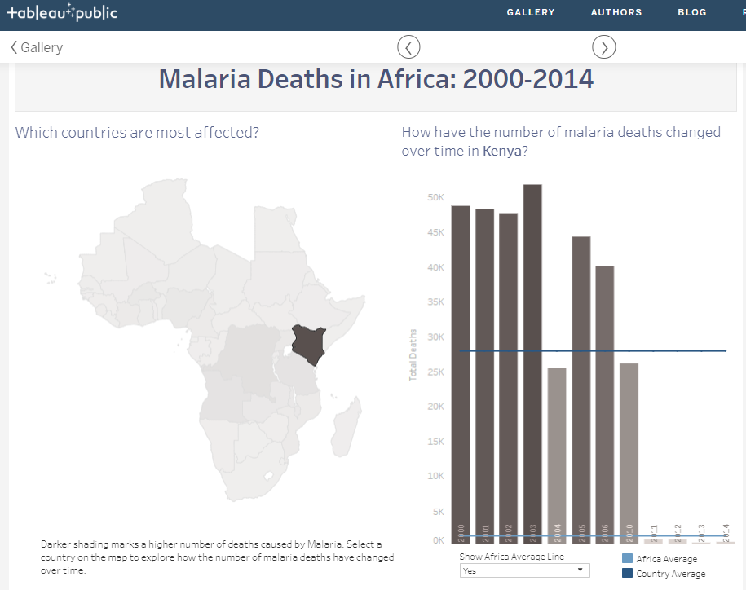

***Interpretation:***

The number of deaths due to malaria in Kenya were below the country average in the years 2004 and 2010. It seems there were either no deaths reported at all for the years 2007-2009, or the numbers were too far down below Africa average for it to show on the chart. I got this data by clicking on Kenya on the map, this displayed the deaths due to malaria for each year since 2000 to 2014, except for the years 2007-2009. Before the year 2004, there were about 47-50K deaths per year. Although the number of deaths had increased between 2004 and 2005, they kept reducing steadily thereafter until 2014.

***Figure 2: Insight number two: ZIMBABWE***

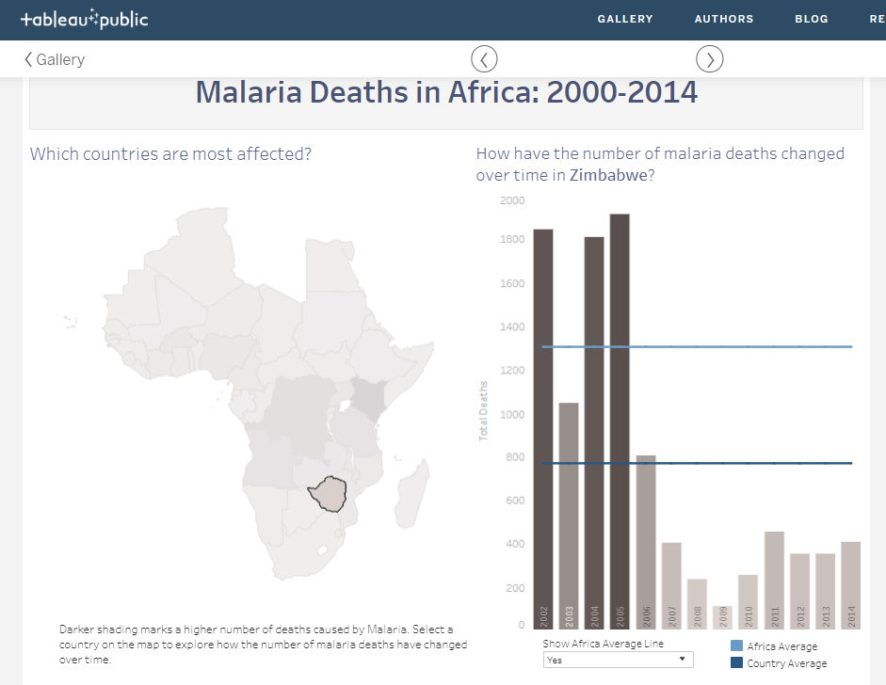

***Interpretation:***

The years 2002, 2004 and 2005 reported the highest number of deaths due to malaria in Zimbabwe with numbers between 1800-2000 per year. Before 2006, number of deaths reported were above the country average, between 800-2000 deaths per year. After 2006, starting in 2007, deaths were reduced to about 400-500 per year. Except for the years 2002, 2004 and 2005, all other years reported number of deaths below the Africa average. I got this data by clicking on Zimbabwe on the map, this displayed the deaths due to malaria for each year since 2002 to 2014. It seems the years 2000 and 2001 had no number of deaths reported, or these numbers were way too low below the average for them to show in the figure above.

***Figure 3: Insight number three: DEMOCRATIC REPUBLIC OF THE CONGO***

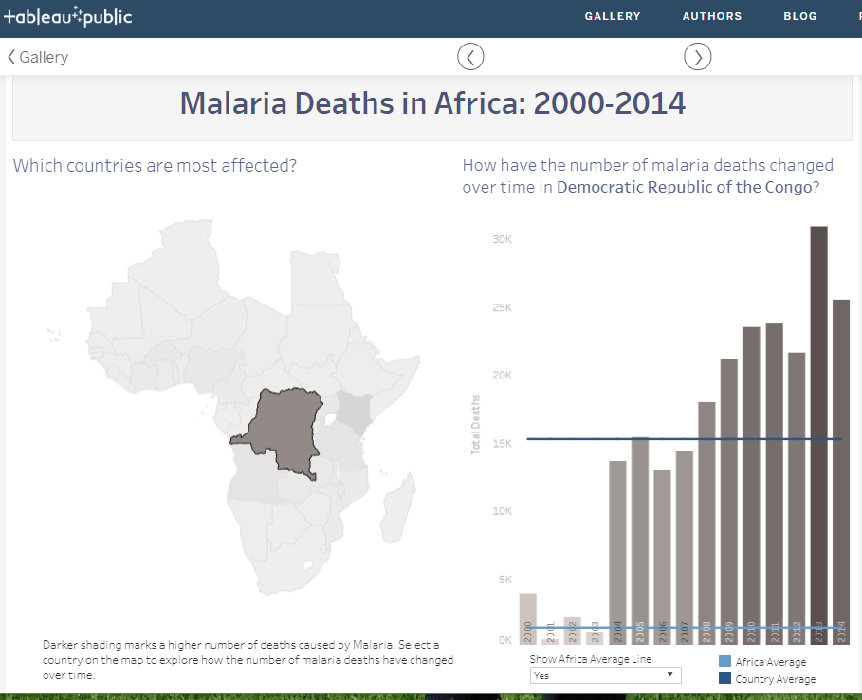

***Interpretation:***

The highest number of deaths due to malaria in Democratic Republic of the Congo were below the average of 15K since the year 2000-2007. The numbers later grew above the average as from the year 2008-2014. The highest number of deaths due to malaria were reported in 2013, this dropped by 5K in 2014. The years 2001 and 2003 reported numbers below the African Average. I got this data by clicking on Democratic Republic of the Congo on the map, this displayed the deaths due to malaria for each year since 2000 to 2014.

**\*\*\*\*\*\*\*\*\*\*\*\*\*\*\*\*\*\*\*\*\*\*\*\*\*\*\*\*\*\*\*\*END\*\*\*\*\*\*\*\*\*\*\*\*\*\*\*\*\*\*\*\*\*\*\*\*\*\*\*\*\*\*\*\*\*\*\*\*\*\***